Assignment 4

## Afia Fahmida Rahman

# 17101240

Question:

1. Use case + Activity diagram (requirement document)

Solution:

The system we proposed in our SRS involves the use of a central server where cameras in different buildings would take livefeed, detect faces, and compare the facial features with the faces of individuals already saved in the central database. If the face of an unknown individual shows up, a notification will be sent to the registrar immediately asking if the unrecognized face is a visitor. Upon confirmation of the approved visitor, no further actions shall be taken. However, if it is known that the visitor is not authorized, security staff intervention shall be required to get rid of the person from BRACU premises.

The use case diagram for the system described is as follows:

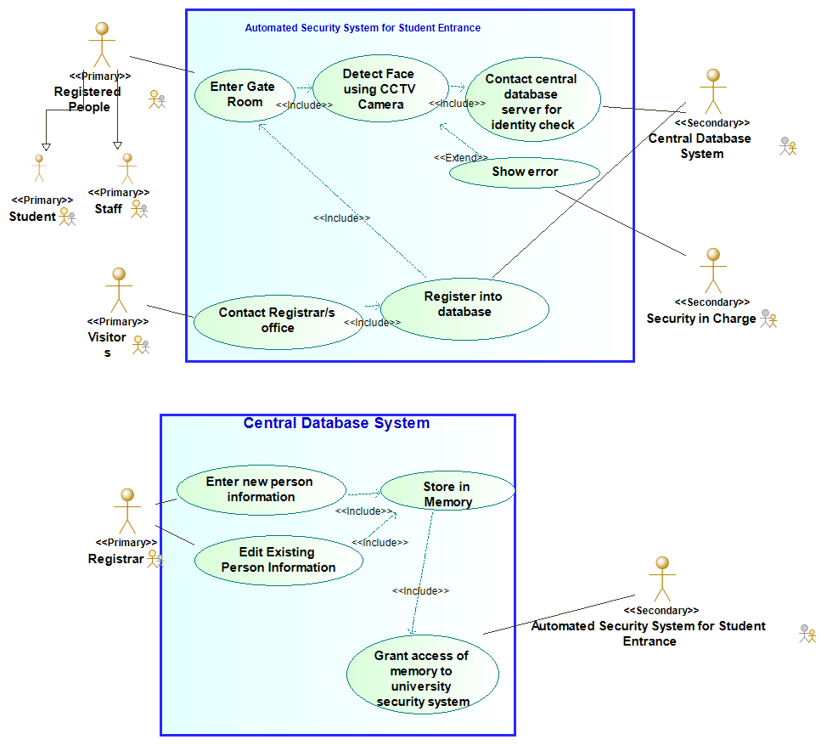

Figure: Use case diagram for the proposed BRACU Entrance System

The activity diagram for the system is as follows:

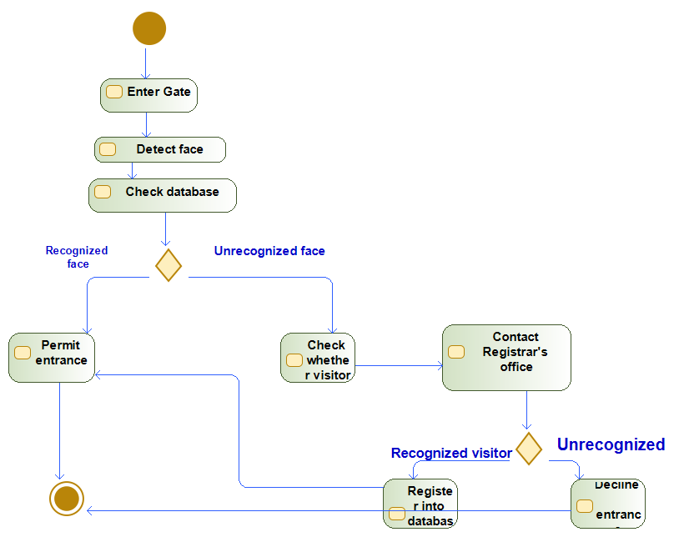

Figure: BRACU Entrance System Activity Diagram

1. Find out test case for Automated Security System for Student Entrance System

Solution:

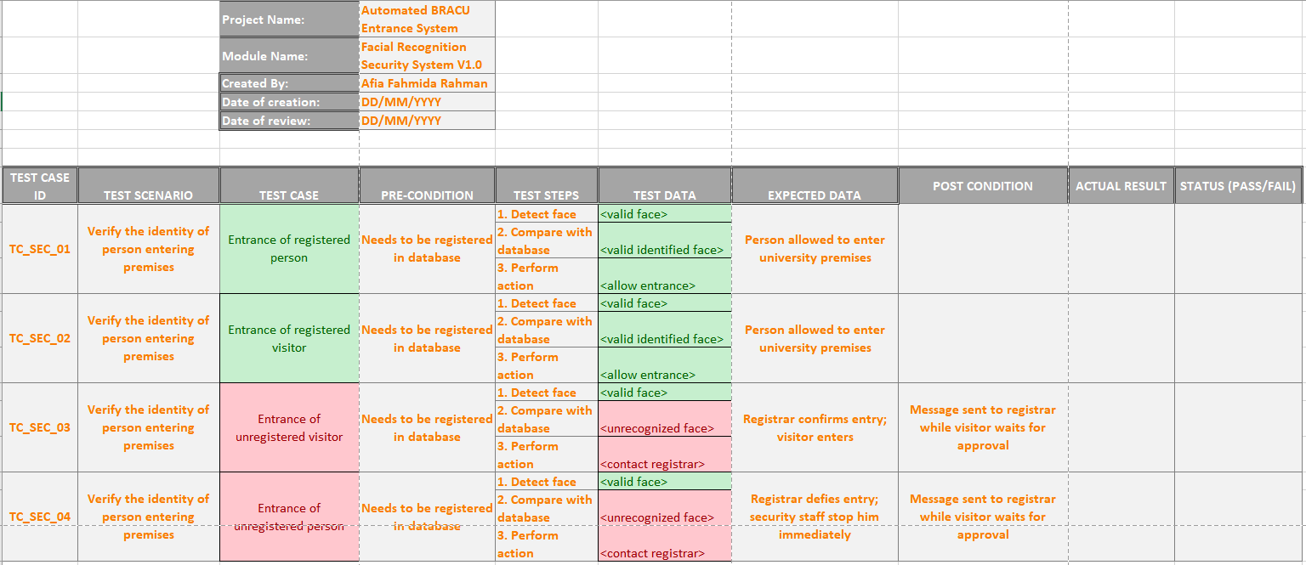

1. Develop task cards for the system

Solution:

